Health and Safety Committee
Wednesday September 16
Hybrid
Agenda
5:30pm | Open Meeting  By Consensus - Approval of Agenda Yes / No  Attendance: Please put your member # and component in your meeting name (as displayed by Zoom) | Chair
5:35pm | Ice Breaker (5 min)  "What is one thing you noticed this week that improved safety, well-being, or ergonomics in your workplace?"  Feel free to share or simply pass if you'd prefer. | Everyone
5:40pm | Chair's Report (5 min) | Chair
5:45pm | Financial Update (5 min) | Treasurer
5:50pm | New Business (15 min)  - Education  - What would you like emphasize on  - Plan for the next meeting | Everyone
 | - H&S capsule - Did you know? See below  - Would someone like to take this on? | Everyone
 | - H&S Scavenger Hunt (October is Canada Healthy Workplace Month) | Chair
6:05pm | Motion to … Discuss purchasing new first aid kits  Motioned: [full name]  Seconded: [full name]  - Passed: Yes / No | Karen
6:07pm | Open Floor  - Would you like monthly meetings  - How we are going to put our resources together and get people more involved | All
6:30pm | Meeting Adjourned | Thank you!

Action Items
Item | Lead | Date
Title of action item | Name of key contact person | Deadline for next update or completion of task

For a Safe and Healthy Workplace
Health and safety at work are everyone’s responsibility. As federal employees, we all play a role in creating a professional environment that is safe, respectful, and conducive to everyone’s well-being.
Prevention and vigilance

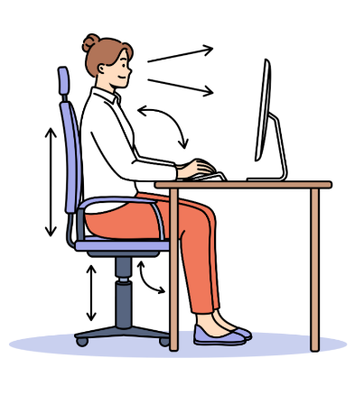
Keep your workspace clear and ergonomic: adjust your chair, monitor, and keyboard to help prevent musculoskeletal issues and reduce fatigue.


Keep work and passage areas free of obstacles.


Report any potential hazards without delay (loose electrical cords, defective equipment, slippery surfaces). Prompt action helps prevent accidents.

Why it matters
Even a minor incident can have serious consequences. Prevention protects our physical well-being, reduces stress, and supports a safe and secure work environment for everyone.
Together for a safe workplace
Every action counts. By staying attentive and proactive, we foster a workplace where health and safety are shared priorities.

